|  |  |
| --- | --- |
|  | Use Cases |
|  |  |
| Generated 3/15/2015 | 350project |
|  |  |

Contents

Use Cases 2

UC-1 - Keep track of assignment due date 2

UC-2 - Create a new assignment 2

UC-3 - Remind time , location ........... 2

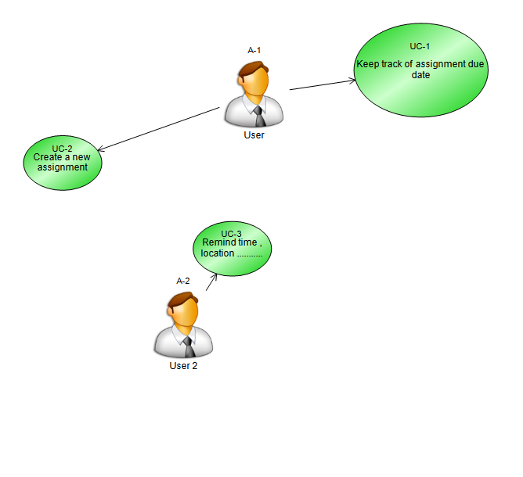

# Use Cases

### UC-1 - Keep track of assignment due date

A user want to know when the project is due (month/day/ year).

#### Main Success Scenario

1. The user simply click 1 week , 2 weeks , 4 week , All projects button.

### UC-2 - Create a new assignment

When a person wants to create a new assignment , he/she just needs to choose "New Project" in the file a menu.

|  |  |
| --- | --- |
| Preconditions The person who wants to create new project/homework must know project 's name , date assigned , due date | Success Guarantee |

#### Main Success Scenario

1. User chooses to create new project.
2. System asks user name of project , Due date , category , notes , number of sub projects.
3. User click ok to create project.

#### Extensions

### UC-3 - Remind time , location ...........

#### Main Success Scenario

#### Extensions